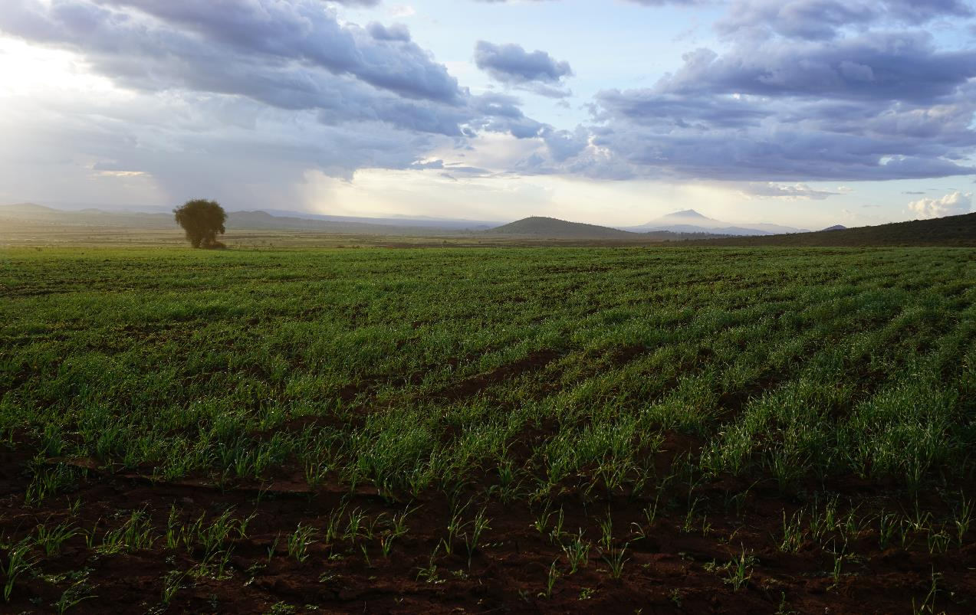

**Transforming water and climate security in the supply-chain:**

Farmer engagement and planning phase: Report, April 2017

**Executive summary**

Between March 2016 and March 2017, the water and climate risks affecting the supply-chain of Serengeti Breweries Limited (SBL) in Tanzania were investigated by a team of local and international experts. The purpose of this work was to identify the challenges facing producers and the reliable supply of inputs – in particular, barley - and to plan with stakeholders for how these can be addressed to reduce risks to SBL’s operations, farmers and their communities. As well as supporting the sustainability of SBL’s business model, this work aligns with Diageo’s Water Blueprint, and meets requirements of the Alliance for Water Stewardship Standard which is being implemented by the Moshi brewery. As the first brewery to implement the standard, and the first detailed analysis of small-holder water/climate risk mitigation, the work is globally pioneering and makes a significant contribution to improved corporate sustainability practice. The work also supports implementation of the SAI sustainability tool and EABL’s wider sustainable agriculture support package.

The team undertook a literature review, met with 50 farmers in three barley growing areas: Hanang, Likamba (Arusha) and West Kilimanjaro and used participatory methods to identify the problems faced, and prioritise potential solutions. Data was triangulated against expert inputs and focus group meetings with Village leaders, District and National Government Officers, SBL, and experts in the wider NGO and farming communities.

Key findings are summarized here along with proposed next steps. Findings and analysis are supported by detailed field reports included as Annexes 1 and 2.

**Key findings**

1. **The current situation is not sustainable for barley farmers or SBL**. Farmers face a range of severe climate and water related risks which undermine the quality and quantity of production, and the viability of barley growing in the future. Because of crop failures associated with drought and erratic rainfall, some farmers have had assets seized by banks because of an inability to repay loans taken out to invest in barley production. If SBL is serious about securing the long-term supply of barley from within Tanzania then action is required.
2. **Water management, agronomy, soil fertility, productivity, security of land tenure and climate resilience are closely inter-related**. For example, organic matter content determines soil water retention and crop vulnerability to erratic rainfall. Vulnerability is also determined by financial services and decision making by the farmer, and by security of land tenure. Productivity cannot be addressed without addressing water risks, and water risks cannot be addressed without considering holistic farm management.
3. **There is currently no support for SBL barley farmers to mitigate water risks**, including drought, and this needs to be delivered as part of a wider model of integrated support from EABL.
4. **Support and interventions need to be cost-effective, proportionate and tailored**. This is because the nature of problems faced and their solutions vary depending on context. For example, farm size and landholding arrangements vary, with farms in West Kilimanjaro tending to be larger but with relatively insecure annual land lease from the government (or landlord) and direct contracts with SBL. This compares with Likamba where farms are much smaller but tenure more secure, and contracts via a hub and spoke model.  In some areas water supply and sanitation is a problem, whereas in others, soil erosion and water and land conflicts are the priorities. Not all issues/solutions are common between areas but the following table captures key generic challenges and potential solutions.

|  |  |
| --- | --- |
| **Supply chain/farmer challenges** | **Potential solutions** |
| **Water availability**  Erratic rainfall – late onset and low totals, coupled with limited groundwater availability, soil water availability and potential for irrigation.  Regular and widespread impact on yield, loss of seed crop and harvest | **Conservation farming training** **and support:** minimum tillage, contour ploughing, rotation, stubble retention.  **General agronomy training**: sowing, fertiliser application, moisture retention, soil fertility, harvest losses.  **Financial and business management training:** risk management, and improved access to and understanding of loans and financial services.  **Weather Indexed Insurance:** research and development of an affordable solution  **Support for mechanisation loans**  **Improved/longer contracts with SBL**  **Conflict management**: between grazing and crop production  **Improved security of land tenure**: through engagement with government  **Strategic deployment of WASH in supply chain communities** |
| **Poor agronomy**  Inappropriate farming techniques  Inappropriate application of fertilizers and pesticides |
| **Soil degradation**  Poor fertility and erosion  Relatedly there is a lack of mechanisation (Likamba), over-grazing and conflict with pastoralists |
| **Poor farm business planning**  Limited financial risk management, business acumen and limited access to financial services |
| **Inadequate access to water and sanitation**  Lack of access to drinking water and sanitation in the community and at field level leading to lost time fetching water, or due to ill health. |
| **Insecure land tenure**  Non-optimal or short term or illegal land leasing agreements.  Limited incentives to invest in land and water stewardship |

**Next steps**

Based on engagement with farmers and consultation with a wide range of stakeholders it is proposed to implement a further phase of work to implement farmer support modules, and to document farmer led evaluation of their adequacy within each area of production. Support modules will include:

1. **Conservation agriculture training** **and support**
2. **Financial/business training** **and support**
3. **General agronomy training** **and support**
4. **Access to weather indexed insurance**
5. **WASH and healthy communities**
6. **Empowerment, rights and obligations**

This next phase, tentatively called Maji SASA! (Water Now!) and documented separately, will lever at least a further €50 000 of investment from GIZ/DFIDs International Water Stewardship Programme, and will:

* Test specific interventions that are tailored to meet needs of all EABL smallholders
* Inform development of pan-EABL generic LRM farmer package
* Develop a model for consistent cost effective identification and analysis of smallholder farmer issues – that feeds into this EABL LRM package
* Share methods and learning regionally and internationally to inform best practice and demonstrate global leadership on sustainability and water stewardship.

**Annex 1. Field report: 21st, 22nd and 23rd March 2017, WWI/SwM**

**1. Introduction and background**

This short report documents the results of the scoping and planning visit undertaken to explore water and climate risks, opportunities and responses facing key stakeholders in the supply chain of Serengeti Breweries Ltd Moshi Brewery. The mission included staff from Shahidi wa Maji, Water Witness, Diageo, DFID and SBL. It builds on earlier work as part of SBLs water stewardship strategy and focuses on stakeholder, community and farmer input to the following questions:

1. **What are the priority water and climate related challenges facing smallholder producers and their communities, and what are their root causes?**
2. **What practical mitigation options to address these challenges are available and how can stakeholders collaborate to implement these?**

Key stakeholders were met either face to face, or in a two participatory group meetings which included 39 farmers supplying SBL, community members and village leaders. The aide memoire which guided the work and a list of all stakeholders met are included as Annexes. Summary findings are presented here for review by partners, and these are built on to develop the proposed plan of action provided separately. Findings from Likamba, Arusha District Council and stakeholder meetings are set out first followed by those from Ngare Nairobi and Siha District Council.

**2. Findings relating to Likamba/Arusha farmers:**

1. **Arusha District Council, key insights:**

* District has experienced rain shortage of over the past 5 years, and previously, resulting in low yields in crop production.
* The District is aware of farmers cultivating barley but previously they had understood that all barley was cultivated for TBL.
* The District does not provide support to farmers with contracts to TBL/SBL because they consider that they receive enough support already.
* Water quality is not thought to be a significant issue in Likamba village (Note – though worth checking for elevated fluoride).
* The NGO OIKOS is working on climate change interventions in Oldonyo Samba and Ngarena Nyuki.
* As is common in the Masaai culture, farmers also keep cattle so soil erosion is concern in Likamba. Average of 700 cattle per household. Pasture becomes a problem during dry period, others migrate to nearby countries (Kenya) in search of pasture, although water conflict is not a major issue in the area. The District provides advice to livestock keepers on proper animal husbandly to reduce degradation.
* Famers require skills in conservation agriculture, and the effective use of manure/fertilizers. Very few famers practice crop rotation with leguminous crops.
* The majority of famers use the back-pack sprays to spray their farms with insecticides/pesticides.
* The area has very low potential for irrigation because of shortage of water sources. Even the potential for chacco dam construction is limited due to the nature of the sandy/loose soils in the area.
* Current data on population with access to water indicates that, 57.9% of the District population has access to clean, affordable and safe drinking water from various improved sources (Source: District Strategic Plan, (DRAFT), 2017).
* Climate change in the district, affects availability of pasture, livestock feeds and water due to inadequate and unreliable rainfall. The result of climate change has forced many farmers to migrate from one area to another searching for water and pasture which results in some conflict between livestock keepers and farmers
* Land related conflicts. The biggest challenge which is facing the Department of Livestock and Fisheries is onflicts with the neighboring district councils as result of unclear boundaries.
* Untimely fund disbursement to the District leads to the failure of the most planned activities.
* The District is not aware of Weather-indexed insurance systems, but suggest that it be explored further and introduced to famers.
* The District is ready to co-operate with SBL on this project.

**Note:** The team are also following up to obtain more detailed demographic/population, economic and health data.

1. **Farmers meeting Likamba Village:**

Within a participatory session, 26 farmers and community representatives reviewed the key issues and identified the following impacts, solutions and recommendations.

|  |  |  |  |
| --- | --- | --- | --- |
| **Issue** | **Problem/Impacts** | **Potential solutions** | **Recommended steps** |
| Climate change/  Rainfall variability | * High temperatures and regular low rainfall means that harvests are often under 40% of expected yield. * Shortage of pasture means that reduced rainfall leads to death of livestock, reduced income, and conflicts over grazing/land. * The impacts of low and variable rainfall are hunger/malnutrition, poverty and migration of youth to better places. * Likamba also suffers flooding and erosion in heavy rains. | * Proper/improved livestock keeping * Use of drought tolerant seed varieties * Sustainable and effective use of manure/fertilizer * Training on conservation agriculture * Soil testing and improved advice * Tree planting | * Provide better and regular training to farmers * Enforcement of law and bylaws on environmental management * Research and development (into what?) * Find out more about weather based index insurance * Rain-water harvesting * Training on barley quality * Training and advice on financial planning and risk management for farmers |
| Water supply, sanitation and hygiene | * There is a shortage of water for domestic use (women need to travel long distances to fetch water) * High disease occurrence (Malaria, flu, etc) * No toilets near public meeting places such markets, village office * Inadequate community awareness on sanitation and hygiene | * Sustainable water supply and sanitation project | * Construct public toilets as demonstration plots * Training on sanitation and hygiene * Better planning for water supply |
| Water quality | * Salty drinking water could be harmful to livestock and plants (cause weak joints and wilting vegetables/plant) * The safety of water from open dams is not guaranteed * Health problems (weak joints??) | * Conduct water quality test for drinking water on the effects of sodium bicarbonate and salt in Likamba * Regular water treatment * Provide additional water supply infrastructure (complete the existing SBL borehole) | * Water safety planning |
| Soil erosion/  degradation | * Loss of soil fertility (shortage of fertile land for cultivation of barley * Destruction of infrastructure * Less harvest and income | * Tree planting * Training on animal husbandly * Planting drought tolerant seeds * Use of organic manure * Conservation agriculture * Training on environmental management * Law enforcement * Change of attitudes | Erosion control planning and training  Conservation farming |

**Additional notes, village meeting**:

* There is only one collection water point for domestic use within the village that is functioning, fed by a borehole. Distance to the nearest other source is more than 3 km. The former water supply project was closed due to management issues as people were not paying for water.
* Women walk 6 hrs day in dry season, time otherwise spent in the field.
* Weather index insurance- farmers think is a good idea and potentially an ideal mechanism to minimize the impact of crop failure. *Insurance? This would help us live through drought.*
* 800 households, around 80% have toilets
* Field sanitation is poor but not too far from homes. It would be useful to have water in the fields.
* Long-term contracts with SBL would be useful
* Demo-latrine would be useful
* Consider a due-diligence process ahead of contracting – entering into the SBL supported scheme.

***Next steps:*** share report and develop and test package of support May-July; detailed questionnaire; GPS of farms and planning meeting in May

1. **Mviwata, Arusha, Richard Masandika, Coordinator**

* Mviwata organizes SH farmers into groups and networks to support their development, to strengthen their voice in decision making, and to lobby and advocate on issues that affect them.
* 7000 individual are members around Arusha with 340 groups registered, each paying membership fees (Tsh 5000)
* 5 projects with support from 4 donors:
  + Production issues
  + Lobbying and advocacy
  + Capacity building
  + Markets
  + Processing
  + Value add
  + Financial management training and book-keeping
  + Environmental management (climate, conservation ag., inputs use, water)
* MoU in place with Gov
* Impact evaluation every 3 years
* Farmers in Monduli Juu and Likamba
* Historically rainfall was enough but patterns have changed particulatly around the March – April window with onset increasingly early and volume variable.
* Irrigation costs are very high – only seasonal rivers and gw often salty. If farers are well organized its possible but loans available are too small.
* Land security is a big issue. Certificates of Customary Right of Occupancy can be developed and land use planning supported. V beneficial so far.
* Yields generally low due to soil fertility, poor seed quality and use of inputs, plus post harvest losses.
* WII is not available yet – we are promoting FIT approach set up in Uganda, in Tanzania.
* The problem is accessibility and education of farmers - good test is if they have health insurance
* Farmers use MPESA
* Check Oikos – Stephen Luvuga

1. **Michael Denis, Field Master (Hub and spoke lead farmer) 0622 327630**

* Big problem facing resilience and improved farming is lack of aaccess to equipment and finances for conservation farming. Conservation farming can transform productivity and resilience.
* OM at 1.9%
* Borehole wont work – no water
* Guys are using hand broadcast
* Check Tanzania Gatsby Trust for training
* Financial risk management training would be useful
* Insurance – if youre a good farmer no need
* Seed variety – yes there is an opportunity
* Happy to assist in training on soil moisture and OM management, and analysis on commercial basis.

1. **VECO, Paul Mtuthi, Mary Myina and Mark Blackett, Regional Representative, VECO East Africa, Mobile: +255 687 640790**

* NGO working with 10K farmers in Tz on 5 years programme focused on inclusive and sustainable business models.
* Involved in the KWSP irrigation financing
* Work on:
  + agronomy and farm planning
  + business management: group business planning, needs diagnoses
  + irrigation
  + maize, pigeon pea, rice in Siha etc.
  + Advocacy – there is a gap to take issues to policy level. ANSAF may be best placed there… Agricultural Non-State Actors Forum (ANSAF)
* Insurance: WII – FIT in Uganda takes 15% , Jubilee Tz. In Ethiopia too much subsidy. Aon?
* Potential to collaborate but need to explore strategic fit.

**3. Findings relating Ngare Nairobi/West Kilimanjaro**

1. **Farmers meeting:**

13 farmers and community members were engaged in a participatory session. A slightly different set of questions were posed to elicit more detail on response, as previous visits had taken place to document impacts (see earlier reports). This also explains the slightly lower turn out.

|  |  |  |  |  |
| --- | --- | --- | --- | --- |
| **Issue/**  **problem** | **Solutions** | **Opportunity** | **Obstacles** | **Recommendation** |
| Rainfall variability | * Knowledge on conservation agriculture * Weather based index insurance * Knowledge on financial planning and risk management * Improved weather forecast information | * Basic knowledge exists on conservation agriculture * Experts /institutions are available * Available market for produce * Existence of projects by ACRE, Quality food product. * Farmers group exist to coordinate | * Lack of permanent farming land (Most farmer depend of hiring/renting land annually so are unable/unwilling to invest) * Conflict between pastoralist and farmers (whereby stubble is grazed) * Wildlife encroachment * Climate change * Lack of constitution for farmers group – not registered | * Training on conservation agriculture * Provide permanent farms to Farmers * SBL to secure an estate (discuss with Government to use NAFCO/ KCU farm) * Provide Weather forecast information to farmers * Land use plan * Law enforcement * Farmers training on Weather based index insurance - more research required * Training on Financial management required |
| Environmental degradation (soil erosion, water pollution) | * Proper use of pesticides * Conservation agriculture * Law enforcement * Proper livestock keeping practices |  | * Lack of permanent farming land – this uncertainty restricts investment in cattle fencing, establishment of bylaws and investment in conservation farming | * Training on conservation agriculture * training on agronomic practices * training on WRM/water stewardship * Proper use of equipments for pest control |
| WASH in farming areas | Toilet facilities |  | Lack of permanent farms | * Demo toilet * Training on WASH for communities * Water facility on farming areas |

**Additional notes:**

* Conservation farming: short term leases means we can’t leave stubble – someone will invade with livestock. Solution would be to renegotiate the leases / contracts. We could try the RC or have SBl assist with this.
* We know the methods but we don’t have the land – if we don’t have security of knowing we’ll have the land beyond 1 year we cant plan or invest. We rent NAFCO farmland from government**.**
* If government gave us 700 acres over 5 years we could invest properly.
* Training works best either through visits or external session – best time of year Sept, Oct, Dec-Feb, post harvest.
* Check whether short term lease is a barrier to WII.
* Not registered as a group – no constitution
* Long term financial planning would be very useful.

1. **Siha District Council meeting, Key Insights:**

* Land tenure issues are a major concern for the district, limited land can be provided to famers because most of the land is owned by a few individuals and the government (NAFCO, KCU). The Minister for Land is aware of the problem. Meanwhile the District is reviewing all issued land contracts/certificates to come up with a solution.
* The District has no powers to decide on allocation/rental of government owned land. Directives have to come from the Ministry.
* The land leasing arrangement practiced by land owners to famers is not legally recognized. Landlords were formerly leased land by Agricultural cooperative societies on contract to develop farms for either livestock or coffee production, but instead they opted to establish businesses of re-leasing those farms to small-farmers on temporary contracts. The Government sees this as an illegal business due to the fact that land owners are breaching their original contracts. They also impose difficult conditions on small-famer’s e.g. after harvesting a farmer will be required to leave behind all stubble left over after crop harvest to benefit the land owner as pasture for livestock. Besides, the Government cannot collect revenue from such businesses.
* Negotiation with the District Council should be entered into to review arrangements and to see if it is possible to allocate the farmers long-term contracts.
* SBL could send a formal request to the Ministry responsible for land to allow barley famers to cultivate on long-term contracts in Government estates.
* There is no specific plan for climate change, but there are irrigation projects going on in the district to cope with rainfall shortage. Selian research institute does research on seed varieties. SLMP (sustainable land management project) is promoting conservation agriculture in mountain areas.
* Syngenta and Yala are there as business companies. They basically promote their products to farmers but are not assisting them in any other way.
* Conflict exist between famers and livestock keepers because of grazing livestock on crops /stubble. Grazing is by local and non-local herds.
* Since last year, 3 season’s data shows has decrease in crop production due to shortage of rainfall.
* Siha district barley production for 3 years

|  |  |  |  |  |  |  |  |  |
| --- | --- | --- | --- | --- | --- | --- | --- | --- |
| year | Seasons | | | | | | | |
|  | **Short rain (Vuli)** | | | | **Long rain (Msika)** | | | |
| Ha. planned | Ha. Actual Cultivated/  planted | Estimated production | Actual Production | Ha. planned | Ha. Actual Cultivated/  planted | Estimated production | Actual Production |
| 2013/14 | 350 | 242 | 2,100 | 1,452 | 750 | 680 | 4,500 | 4,080 |
| 2014/15 | 350 | 320 | 2,100 | 960 | 750 | 730 | 4,500 | 2,106 |
| 2015/16 |  |  |  |  | 370 | 366 | 2,197 | 183 |

Source: Siha district report

* Weather based index insurance would be a help to famers if implemented well.
* Irrigation is not possible or very difficult in in Ngare Nairobi because of low water availability, (groundwater only with patchy extent) however, even if and where there is water the lack of secure land ownership/tenure restricts ability of farmers to plan and invest, or drill.
* Water quality and sanitation not a major issue but still there is a need for community awareness on sanitation and hygiene.
* Recommendations for SBL: Provide regular training on proper method of agriculture, agronomic practices, and weather based index insurance. Provide proper seed varieties.

1. **Hans Komakech, Mandela University**

Several relevant studies including SAFI looks at how farmers come to invest in farming. 6 PhDs working on water issues with small-farmers – happy to collaborate.

**Appendix 1.** Stakeholders met:

**Dates 21-03-2017 LIKAMBA VILLAGE**

|  |  |  |  |  |  |
| --- | --- | --- | --- | --- | --- |
| **No** | **Names** | **Position** | **Phone No** | **Acre** | **Harvest (bags)** |
| 1 | SAMWEL SATIN | FARMER |  |  |  |
| 2 | STEPHEN NDUKAI | FARMER |  |  |  |
| 3 | ASHEELI JOHN | FARMER |  |  |  |
| 4 | MITORIS MINYALI | FARMER |  |  |  |
| 5 | MALIAKI ANDREA | FARMER |  |  |  |
| 6 | LOMAYANI MESHURE | VILLAGE CHAIRPERSON |  |  |  |
| 7 | DEOGRATIAS MAGEMBE | AGRICULTURAL OFFICER |  |  |  |
| 8 | LOTTY MOLLEL | FARMER |  |  |  |
| 9 | LOLAJI LUKUMY | FARMER |  |  |  |
| 10 | SINDIYO MEKURETU | FARMER |  |  |  |
| 11 | LAIRUMBE SILANGA | FARMER |  |  |  |
| 12 | ROBERT SAIGILU | FARMER |  |  |  |
| 13 | ZAKARIA ANDREA | FARMER |  |  |  |
| 14 | SAITOTI MZEE | FARMER |  |  |  |
| 15 | ISRAEL . L LONINGO | VEO LIKAMBA |  |  |  |
| 16 | AMOS LONINGO | MJUMBE |  |  |  |
| 17 | GODFREY .H. KIIVUYO | FARMER |  |  |  |
| 18 | JULIU SAMBWETI | FARMER |  |  |  |
| 19 | JULIU ISAYA | BALOZI |  |  |  |
| 20 | MULANI | FARMER |  |  |  |
| 21 | MANGI MESARIKI | FARMER |  |  |  |
| 22 | BABU LOSHIVA | FARMER |  |  |  |
| 23 | LOSERIA KABIKE | FARMER |  |  |  |
| 24 | JUSHUA MUNGAI | FARMER |  |  |  |
| 25 | ALPHAYO BABU | FARMER |  |  |  |
| 26 | ABEL L KISSIRI | FARMER |  |  |  |

**22/03/2017 NGARE NAIROBI VILLAGE**

|  |  |  |  |  |  |
| --- | --- | --- | --- | --- | --- |
| **No** | **Names** | **Position** | **Phone No** | **Acres** | **Harvest (bags)** |
| 1 | BORA MSAKI | W/KILIMANJAROO |  |  |  |
| 2 | GADAZI J. KIMARIO | WEST KILIMANJARO |  |  |  |
| 3 | ISAYA W. MOLLEL | W/KILIMA |  |  |  |
| 4 | KENEDY O. MGHAMBA | W/KILIMANJAROO |  |  |  |
| 5 | MERRY M. NDANGAMILA | WEST KILIMANJARO |  |  |  |
| 6 | SAID MSUA | W/KILIMANJAROO |  |  |  |
| 7 | KAROLY VENANSI | WEST KILIMANJARO |  |  |  |
| 8 | DAVID LYMO | W/KILIMANJAROO |  |  |  |
| 9 | SAM MOWO | WEST KILIMANJARO |  |  |  |
| 10 | DANIEL SANDECOS | W/KILIMANJAROO |  |  |  |
| 11 | RAMA ABDALLAH | WEST KILIMANJARO |  |  |  |
| 12 | JUMA MWINGEREZA | W/KILIMANJAROO |  |  |  |
| 13 | STANLEY E. NKINI | WEST KILIMANJARO |  |  |  |

**21/03/2017 ARUSHA DISRICT COUNCIL**

|  |  |  |  |
| --- | --- | --- | --- |
| **No** | **Names** | **Position** | **Phone No** |
| 1 | PAULOS B. KESSY | AG. DED | 0787432222 |
| 2 | SHEVEDWAZE MWAKYOKOLA | COMMUNITY DEVELOPMENT | 0762990998 |
| 3 | ENG. PARTERNUS DANIEL | WATER ENGINEER | 0767839568/0685447885 |
| 4 | CHARLES O. NGILORIT | DAICO | 0755942097/0683919176 |

**23/03/2017 SIHA District council**

|  |  |  |  |
| --- | --- | --- | --- |
| **No** | **Names** | **Position** | **Phone No** |
| 1 | NICO KAYANGA | AG. DED |  |
| 2 | LUDOVICK MUSHI | DISTRICT COMMUNITY DEVELOPMENT OFFICER |  |
| 3 | BURA MADANGI | LAND OFFICER |  |
| 4 | AMOS BEGASHE | WATER ENGINEER |  |
| 5 | GODWIN MLOKA | DISTRICT LAND LAWYER |  |
| 6 | HABIBU ALLY | AGRICULTURE, IRRIGATION AND COOPERATIVE OFFICER | 0764395050 |

# C:\Users\nickh\AppData\Local\Microsoft\Windows\INetCacheContent.Word\SWM new logo.pngImage result for diageoTransforming water and climate security for supply-chain partners and communities:

**Scoping and planning phase**. Aide memoire for stakeholders. March 2017

Like many companies, Serengeti Breweries Limited (SBL) relies on medium and small-scale agricultural producers in local supply chains for the raw materials essential for business operations. The climate and water risks facing small-scale producers and their communities which may affect sustainable production are therefore a growing concern for progressive businesses like SBL. This initiative builds on earlier work to implement the Alliance for Water Stewardship Standard at SBL’s Moshi Brewery. This identified that farmers supplying the site with barley face a range of water-related risks, including erratic rainfall, flood and drought events, pollution and catchment degradation, regulatory non-compliance, water conflict, and the inadequacy of water supply, sanitation and water-related infrastructure. The aim of this next phase of work is to better understand these risks and to scope, develop and implement collective action with farmers and communities to move towards shared water security. By working with all stakeholders to demonstrate how smallholder resilience can be strengthened this work will have value across Tanzania, and by addressing a gap in international guidance on how to assess and respond to supply chain water risks it will make an important strategic contribution to water stewardship globally.

**Approach and guiding questions**

As a key stakeholder, your inputs and partnership in this work are highly valued. At this stage we are keen to meet with farmers and stakeholders to gather evidence and prioritise:

* water and climate related risks facing smallholder producers and their communities; and,
* practical mitigation options to these risks and their viability.

***It is therefore important to gather information, evidence and perspectives of stakeholders on the following questions:***

1. What role does the stakeholder have in relation to the resilience of small-holder/farmer livelihoods in Tanzania?
2. What are the main climate and water-related problems facing small-scale farmers and their communities in Siha, Arusha, Hanang Districts and more widely in the Pangani and Internal Drainage Basins?
3. What effects or impacts do these problems have on the farmers, local people, the environment and the economy? (please provide as much evidence and detail here as possible)
4. What practical mitigation options are available to reduce or avoid these risks? (are there any clear examples of approaches which have worked elsewhere?)
5. For each mitigation option, what are its strong points, its weaknesses and what are your recommendations for future action?

Table 1. Typical water and climate risks. This table can be used to consider impacts, options and recommendations against each key risk

|  |  |  |  |
| --- | --- | --- | --- |
| Problem/risk | Details, effects and evidence of impact | Mitigation options | Strengths, weaknesses and recommendation |
| **Erratic rainfall and climate variability** |  |  |  |
| **Water quality and pollution issues** |  |  |  |
| **Soil erosion and ecosystem loss** |  |  |  |
| **Adequate water supply, sanitation & hygiene** |  |  |  |
| **Water conflicts and legal compliance** |  |  |  |
| **Other** |  |  |  |

1. Are there any other initiatives aiming to build resilience of smallholder farmers and local communities which you are aware of, or other stakeholders or experts whom we should speak to about this?
2. Are you interested to be involved in an initiative to strengthen farmer and community resilience on climate and water. If so in what capacity? What can your organisation bring to a partnership approach?

**For further details on the work and to get involbved please contact the project leads at Water Witness International** [**nickhepworth@waterwitness.or**](mailto:nickhepworth@waterwitness.or)**g or Shahidi wa Maji** [**pendohyera@shahidiwamaji.org**](mailto:pendohyera@shahidiwamaji.org)

Annex 2. Water stewardship in the SBL supply chain – water risk and opportunity scoping   
  
Field report 13th – 20th April 2016

Introduction

Serengeti Breweries Limited (SBL) obtains raw materials, in particular barley, sorghum and maize through direct relationships with small farmers and on the open market. SBL/Diageo and its suppliers, face a range of water-related business risks, including impacts of erratic rainfall, flood and drought events, pollution and catchment degradation, regulatory non-compliance, water conflict, and the inadequacy of water supply, sanitation and water-related infrastructure. The Alliance for Water Stewardship (AWS) standard focuses stewardship efforts on these risks and in order to demonstrate alignment with the standard the brewery is required, as a basic criteria to: *‘Improve understanding of its indirect water use’* (criteria 2.5); and, as an advanced criteria to: *‘Maintain or improve indirect water use’* (criteria 4.6).

The aim of this piece of work is to better understand the water risks facing SBL’s supply chain and to scope, and develop opportunities for collective action with farmers and communities to move towards shared water security. This work will have significant added value by addressing a gap in the existing international guidance available on water stewardship in relation to how to assess and respond to local supply chain / indirect water use risks. By developing, testing and sharing a methodology for this, SBL and Diageo will make an important strategic contribution to water stewardship globally. This work will enable Diageo to contribute to mitigating shared supply-chain water risks, and deliver commitments within the Diageo Water Blueprint including to:*“Equip suppliers with tools to protect water resources in the most water stressed locations”* [1].

This document reports the findings of initial scoping visits to visit farmers contracted to supply SBL with Barley at Ngara Nairobi in West Kilimanjaro, and at Katesh and Basotu in Hanang District. It sets out the main water-related challenges and potential responses, and proposes next steps for future work.

MethodologyThe approach involved interviews and focus group discussions with groups of barley farmers, most of whom have contracts with SBL to supply barley, together with discussions with SBL agricultural / supply chain management and support staff (Musa, Shafi and Peter)[2].

* Three important production areas were visited (see Map 1) to assess the range of water related challenges faced in different geographies/communities.
* Meetings using a participatory approach to avoid researcher bias/influencing of farmer responses, and to manage expectations.
* Key facts/issues were verified via triangulation between different informants, and insights supported by site/farm inspections and analysis of secondary data/literature.

Map1. 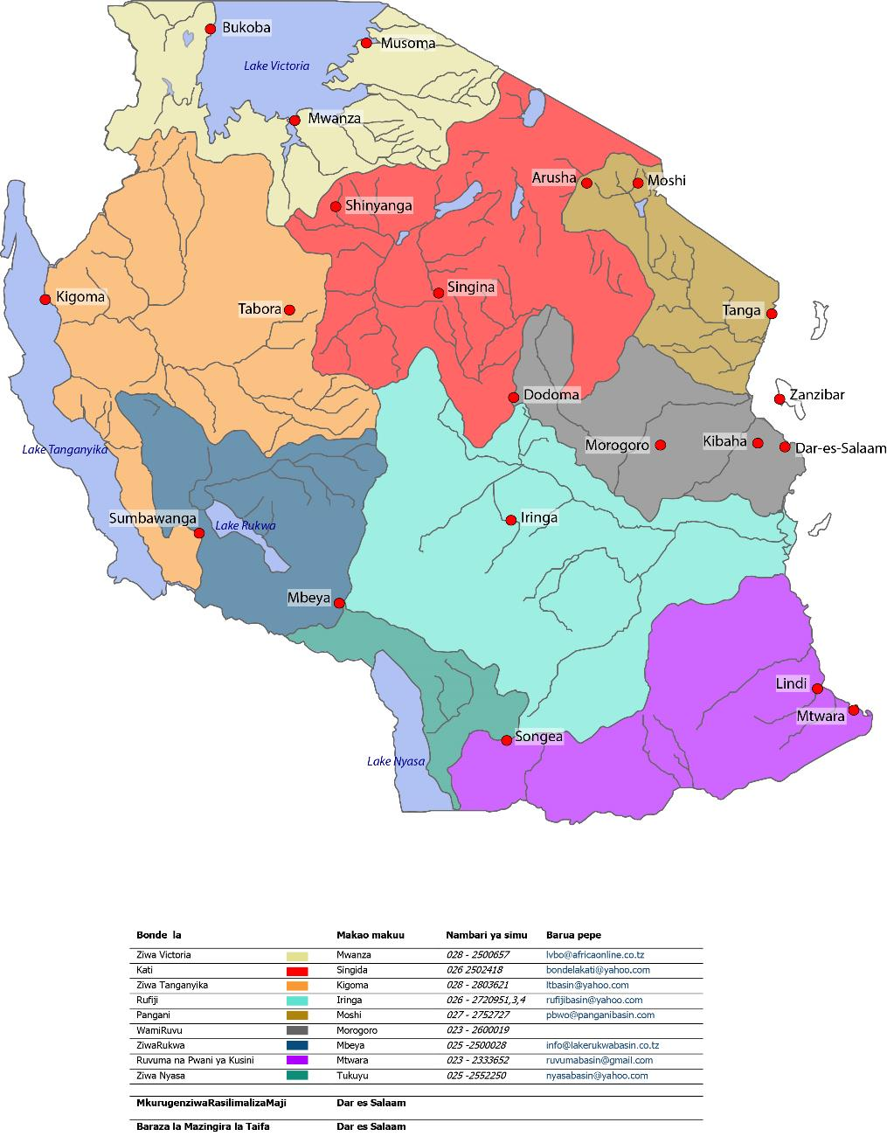

Likamba, Arusha

West Kilimanjaro – Ngara Nairobi

Basotu, Hanang

Katesh, Hanang

**Contextual background**

24 farmers were visited in total (6 in Basotu, 2 in Katesh, 16 in West Kilimanjaro growing barley on between 25 to 270 acres, alongside and in rotation with beans, wheat and in some cases potatoes. The majority of farmers were under a relatively new contractual arrangement initiated 2 to 3 years ago to provide barley to SBL, under an arrangement where they received free seed and a guaranteed market. Contracts run on a 3 year renewable basis. Some had grown barley historically for Tanzania Breweries Limited, but said they preferred to grow for SBL because of direct payments and avoidance of middle-men. Other buyers/TBL had a poor relationship with the farmers.

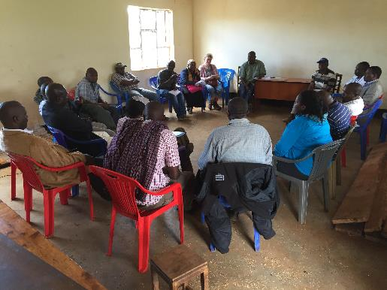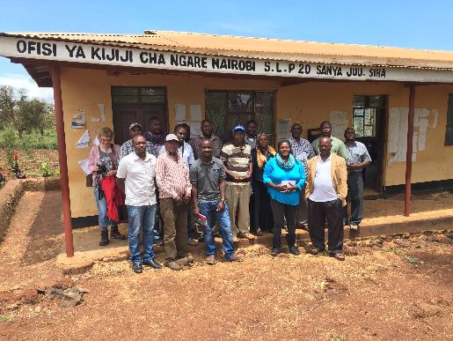

**Plates 1 and 2: Group discussions with farmers at Ngara Nairobi, W. Kilimanjaro**

SBL began engagement with local farmers to grow barley in 2013 in response to CSR drivers and tax benefits available from the Tanzanian government for sourcing local raw materials. Local production is also cheaper and ‘less hassle’ than imported grain from Europe. Farms are classified by size:

Small farm: <20 acres

Medium sized: 20-50 acres

Large farm: >50 acres

SBL approaches farmers via its agents and Village Chairpersons, and provides training via a farmers day and up to two extension visits each month. Farms receive a survey with GPS logging to establish farm size, and some have soil analysis (though some farmers weren’t aware of this). A farm ‘package’ is then developed and inputs (fertilizer and pesticides) and training on application and use is provided by a third party (Yara, Syngenta Crop Care etc).

On securing a contract with SBL farmers then secured a loan - of upto TZS 50M (£16K) - from CRDB bank to pay for inputs such as tractor hire, fertilizers, pesticides, fungicide and herbicide. Some had not yet secured a contract or loan because of challenges in obtaining a certificate of occupation and a copy of title deeds. Only one farmer owned his own land, the rest were renting from the government or others.

SBL currently has 70 farmers on its books, but is aiming for 100. The biggest challenge facing SBL is that it can’t get the quantity of barley it ideally requires from local sources. A new seed variety suited to local conditions is under development via EA Malting. A kilo of barley seed is TZS 1500. SBL has distributed some TZS 400M of free seed.

The Private Agricultural Sector Support (PASS) Trust (a donor funded initiative supporting small farmers) is involved (although the role needs to be clarified) but farmers said they’d received no training or guidance on financial planning or management.

**Findings**

1. **Water availability, erratic rainfall and climate variability (Sustainable Water balance)**

The most significant water-related challenge facing farmers (and SBL) is unreliable rainfall[3]. Rainfall is needed after sowing to germinate the barley (first 3-4 weeks), and again when the plant is ‘booting’ (after about 55 days). Around 600 mm of well distributed rain a year is needed. Lack of rainfall at the right time can affect yield or cause complete failure, and affect plumpness/grading. Several farmers reported complete loss of crop both this year and last year because of erratic rainfall.

Farmers appear to be highly vulnerable to unreliable rainfall in terms of its timing, duration and total amount. Financial vulnerability is a particular problem given that farmers are taking out relatively large loans (up to $20 000) based on SBL contracts at interest rates of 23% with payback terms of 1 year, and are using homes as collateral. No farmers have been able to fully repay the loans, and two farmers have had their houses repossessed, with others facing this process imminently. There were suggestions that some of the borrowed funds had been misallocated by farmers themselves, although consensus was that the high financial investment required for barley combined with erratic rainfall resulted in inability to service loans, and that this was a severe and genuine problem. Some said that they would/were planning to switch to other crops because of this.

Farmers said they’d received no training on financial planning or management.

During the first 3-4 weeks after planting, barley needs rainfall. Farmers use their experience and listen to the forecast from the Tanzania Meteorological Agency via phones and radio to decide when to sow.

Heavy rainfall experienced in the area can cause waterlogging but the crop is fairly resilient to rain damage (though see notes on soil erosion in 3 below).

**Potential responses:**

|  |  |  |
| --- | --- | --- |
| **Option** | **Challenges and background** | **Notes/next steps** |
| **Irrigation (borehole or via new storage)** | * Very expensive, and long term returns only (>10yrs) * Farmers don’t own the land and therefore unlikely to invest * High risk solution vis-à-vis externalities * Boreholes attempted at W.Kili – low yield | Doesn’t appear immediately viable though benefit in exploring:   * technical and financial viability; * support and finance available from GoT, 2030 WRG etc, donor programmes |
| **Improved weather forecasting** | * Already available via phone, radio and internet * Some value but too unreliable (40-25% accuracy according to farmers) * Zonation poor for Basuto farmers as they are on the edge of region * Farmers planted and lost twice this year based on forecasts. Trust is low | Farmers used forecasts but reliability is low. Potential for exploring:   * Reliability of forecast; * Advocacy/partnerships for improved forecasting service; * Improved decision making in uncertainty (links to LSE research) |
| **Weather Indexed Insurance** | Based on regular premium payments and payout on failed rainfall   * Not currently available * Insurance companies refuse without irrigation * Expensive for farmers (perceived) * Exists elsewhere (Ethiopia) but dependent on proximity to hydromet station | This option was popular with farmers and there is potential to explore:   * Efficacy and operating conditions of WII elsewhere in the region; * Constraining factors in Tanzania and broad viability; * Appetite and interest of insurance companies / partners to trial a scheme.   Diageo may be able to broker/provide/support this at a scale which makes it viable. This could be a major contribution in the region.  Farmers should be recording hydromet data and be provided with kit as a matter of course. |
| **Improved seed varieties** | Farmers considered that the seed variety provided by SBL was of poor quality and / or not well suited to local conditions. | Additional effort to develop a seed variety better suited to local conditions. |
| **Improved financial planning** | Given the challenges set out above regarding ‘hard’ solutions, farmers could be supported via improved financial planning advisory services and training. The current loan arrangements appear to be non-viable. | Development and delivery of training and mentoring support for farmers to improve financial / farm-risk management and planning, in particular to adequately plan for weather/financial shocks by spreading risk more appropriately.  Alternatively – advocacy of improved farmer training and extension/advisory services. |
| **Higher returns** | Farmers said that the price paid for barley by SBL was too low, and undermined viability, given the $ related fluctuations/increased input costs since signing of contracts. | Review of final Barley price or innovative payment arrangements conditional on good farm management/risk management practice. |
| **Conservation farming** | One farmer in Kilimanjaro (Mr Musha) was practicing conservation farming techniques and claimed that it was an effective measure to retain soil moisture and mitigate against unreliable rainfall. Other farmers had heard of this but weren’t currently practicing as they had not been exposed to it. | Explore efficacy of conservation farming to mitigate rainfall risks.  Provide farmer led training (and/or incentives?) for uptake or advocate for the same. |

1. **Water quality and pollution issues (Good Water Quality)**

Barley growing has potential to exhaust local soils and so both manures and fertilisers are applied, and crop rotation with beans etc. practiced. Yara Miller fertiliser is used along with DIP(?) – around 1 x 50kg bag per acre. The sales companies are not well trusted, with salesmen historically suggesting that double that requirement is needed. Over-application, or inappropriately applied fertilisers may result in nutrient run-off and eutrophication/pollution of local waters, as well as unnecessary costs to farmers. Whilst there was no clear evidence of this there is no monitoring in place to identify such problems.

Technical advice is provided on the use of pesticides and herbicides by suppliers, and Diageo requires safety measures to be followed. However, good practice and competence in safe use of agricultural chemicals was not in evidence. Farmers followed dosage advice written on the packaging and spraying is generally done by knapsack and with multiple chemicals mixed up in one tank in the field (bactril – broadleaf; Raron super – grasses; Swing – fungicide; Karrot – insects). Applications need to be repeated after rainfall so a forecast is also important here. Farmers reported that, if it rains ‘it all washes off’. Crop burn through over-application was reported as a problem. None of the farmers used or had safety gear and they hadn’t received, or didn’t rate highly the training received or the quality of advice. Safe mixing, preparation, washing and disposal practices were not in evidence. Whilst there is no evidence for health or environmental impacts arising from use of chemicals, no monitoring is in place for this. Based on information available, the use of agricultural chemicals presents risks to the water environment and human health.

|  |  |  |
| --- | --- | --- |
| **Option** | **Challenges and background** | **Notes/next steps** |
| **Improved training, equipment and infrastructure for safe and effective use of fertilisers and pesticides.** | * Training and advice provided by product sales teams – limited trust and questions over quality. * Safety gear not used and best practice (mixing, use and disposal) not in evidence. | A more robust system of advice and support could be devised and delivered involving independent advice and support on:   * Nutrient planning and agronomic advice; * Safe use, handling and disposal.   Alongside this – provision and ensuring use of safety equipment and appropriate wash down/disposal facilities.  Or advocacy on the same.  Potential for monitoring/research on reduced inputs/effective use and pest control. |

1. **Ecosystem degradation, erosion and WASH (Important Water Related Areas)**

Although erosion control is a challenge in the area of study and across Tanzania, barley farmers did not consider this to be a pressing problem on their farms. Evidence of severe erosion was seen locally to the farms (see Plate ). Compliance with the generic statutory set back distance of ‘no human activity within 60 metres of a watersource’ is likely to be a challenge (see 4).

Negative impacts on important water based ecosystems is likely to be limited to water quality problems, although given the proximity of some farms to boundaries of national parks, encroachment and deforestation, headwater degradation are potential problem.

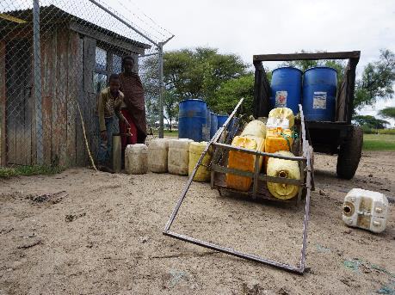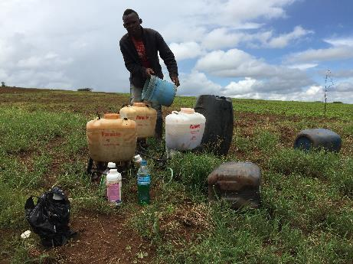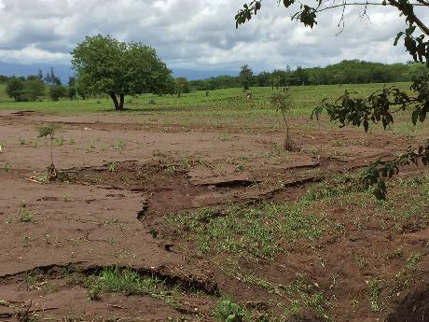

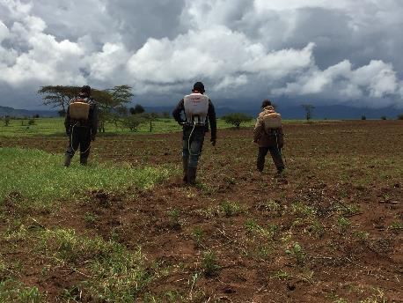

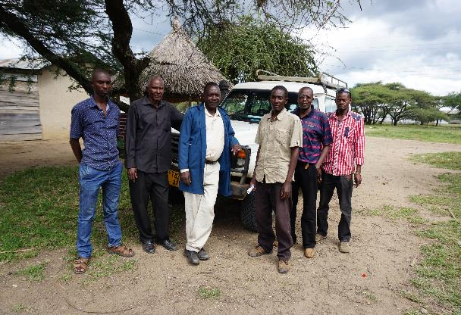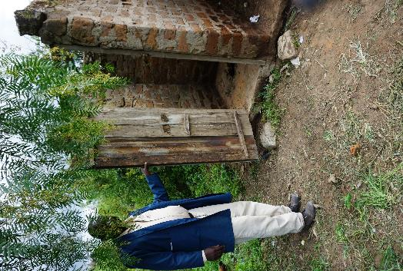

**Plates 3 – 8 clockwise from top left: soil erosion is a significant problem in the areas where barley is sourced (though note this image is not of an SBL farm); pesticide and herbicide mixing/preparation; main tap stand in Basotu village - no water for several days; Basotu farmers; typical sanitation provision Basotu; pesticide spraying West Kilimanjaro.**

The adequacy of water supply, sanitation provision, and hygiene practice/awareness, both at farm scale and within the communities where farmers live and draw their workers is an important aspect of water security – and will interact with community/worker health and wellbeing, economic and livelihood impacts. Farmers did not consider water-related disease to be a very significant problem within their communities, although secondary data suggests that the local situation mirrors that found elsewhere in Tanzania with limited access to improved and reliable services, with elevated levels of associated ill-health as a result (For example, based on 2008 Agricultural Census data, (NBS 2012): 60% of Hanang District relies on unimproved/unprotected water sources and only 6% have improved pit latrine. 12% of households had no latrine. We are still looking for more recent data and health data ).

Problems with adequate water supply and sanitation varied from site to site. For example, in West Kilimanjaro, a reportedly reliable gravity fed supply system is in place. In Basotu, the community is reliant on a gravity fed scheme from Mt. Hanang, some 10 km away, and this scheme sees regular problems. For example, at the time of the visit the village had no water for 4 days because heavy rains had washed out/damaged or silted the pipework. Sanitation provision in worker communities appears of low but variable adequacy. As is the norm, water and sanitation provision at the farm scale – serving workers – is non-existent and a low priority for farmers (although women do comprise some of the workforce).

|  |  |  |
| --- | --- | --- |
| **Option** | **Challenges and background** | **Notes/next steps** |
| **Improved on-farm WASH provision** | * No WASH provision at farm level * Seasonal work force and high costs mean farm level infrastructure may not logical/viable (unless scale makes sense). * WASH advice/training and water carrier/bottles and trowels to cover open defecation are an option | * More detailed analysis of current practice / WASH problems and farmer deliberation. * Trial/costing on provision of worker water carriers and trowels/advice and action pack. |
| **Action to improve security of WASH provision at community level** | * Whilst farmers do not consider WASH to be a priority, it is likely that opportunities to improve domestic water security, sanitation and hygiene exists within their communities (both their own and their workers). * Problems/challenges are context specific which necessitates context specific responses – ranging from targeted community awareness on WASH; investment in infrastructure/O&M (possibly combined with sewage/pit sludge re-use as fertiliser); advocacy and monitoring of service provision by local authorities/providers; support for community WASH committees. * Community water safety planning / security planning lends itself to a context appropriate and locally owned responses which can be monitored to demonstrate efficacy and impact. | * Initiate and support community water safety/water security planning and action in target communities. * Additional data/mapping required to target these efforts. * This work will also generate locally owned evidence for national advocacy on improved water service provision. |
| **Best practices for ecosystem protection** | * Barley farming poses risks of encroachment into headwater forests/riverbanks and of soil erosion. * Little information exists on extent and interactions here. | * Additional data to be gathered and analysed via farmer survey and meeting. * Inclusion of erosion control and ecosystem protection criteria in farm plan/’package’ |

1. **Compliance, conflicts and institutional support (Good Water Governance)**

Given that only one farmer encountered during this work is practicing irrigation, requirements for water use permits, or waste discharge permits are likely to be minimal – although if irrigation is developed it will be vital for farmers to have statutory permissions in place. Community water schemes will require WUPs to ensure long term security of tenure and these are not thought to be in place at the moment.

Conflicts were reported over water and land between farmers and pastoralists (who have traditionally used upland areas for grazing). Specifically, conflicts have arisen due to pastoralists allowing cattle to graze on cropland, and due to breakages in to community water supply systems to access water for pastoralist communities. Conflict resolution appears to be weak, with farmers resorting to guarding fields at night in affected areas.

Institutional support for farming communities appears to be typically low, for example in terms of the agricultural extension, and forecasting services and targeted effort to improve land, water and livelihood security (Only 17.4% of farmers in Hanang received agricultural extension messages (NBS 2012) and note formal agricultural education of farmers is low in Hanang wih 0% of heads of farm households attending tertiary education, compared to 26% in Babati). Farmers reported that agricultural extension staff had visited them but the knowledge held and shared had limited value/relevance. Farmers appeared to be organised through co-operatives with opportunities for strengthening these.

|  |  |  |
| --- | --- | --- |
| **Option** | **Challenges and background** | **Notes/next steps** |
| **Awareness on legal frameworks and statutory requirements relating to water** | * Limited understanding of legal frameworks relating to water and land use risking impacts on farmer’s resource security, and of non-compliance by farmers. | * Development and delivery of water security training containing simplified messages, advice and guidance (already availiable). |
| **Conflict management and improved advisory services/institutional performance** | * Government (and alternative) support for farmers across a range of service / advisory areas appears weak – including on conflict management. * Detailed water security planning with farmers will enable further diagnoses of needs and evidence of current provision. | * Opportunity to develop a detailed understanding of institutional support / challenges facing farmers and development of advocacy messages, or more practical response (bespoke advice to farmers). |

**Recommendations and next steps**

The scoping exercise has proved valuable in:

* Elaborating important water-related risks facing farmers and SBL. The economic hardship associated with erratic rainfall and water availability, poor harvests and failures in loan repayment in particular poses operational and reputational challenges. There is potential for impact on the supply of barley and SBLs targets for local sourcing where farmers move to other crops, and for adverse reputational implications if doing business with SBL results in farmers losing their homes.
* Testing and demonstrating the appetite of local farmers to work with SBL and others to address the range of water related challenges identified. Farmers appear knowledgeable and discussions about challenges and potential solutions were well-informed and thoughtful – expectations of what SBL could do to help were realistic. There seems a clear opportunity for collaborative work to address these challenges and so secure long term benefits for farmers, their communities and SBL business.

The following next steps are proposed following further consultation and agreement with SBL/Diageo and interested stakeholders:

1. **Desk study and literature review**: collation and synthesis of state-of-the-art knowledge on solutions scoped. For example, status and efficacy of Weather Indexed Insurance in East Africa, availability of improved forecasting and seed varieties, pollution control advice etc.
2. **Supply chain water risk mapping:** asimple water footprint mapping exercise across all SBL inputs to ensure that all significant water-related risks are identified and understood.
3. **Questionnaire survey:** Based on this scoping work and results of i. above, we intend to administer a short questionnaire in Swahili with all SBL farmers which will give much greater detail on the water-related challenges they face, helping to inform sensible responses, and allow geographical targeting of these based on local priorities. The questionnaire and framework for analysis (which will sort and rank risks, and allow for mapping of these) will form part of the globally transferable methodology.
4. **Guidance and training development:** Drawing on the results of the above, bespoke advice and training materials will be developed.
5. **Farmer meeting/learning event:** Drawing on the analysis and materials above, farmer representatives will be gathered nationally to review findings and co-develop / refine response plans. The event will involve two way exchange of information – awareness raising and skill development for farmers, and participatory input and ownership of interventions to be delivered in vi).
6. **Intervention development and piloting:** Depending on the viability and refinement of response options, this step will see interventions piloted and reviewed in one or more geographies to generate learning, evidence and guidance for scaling up.
7. **Sharing methodology, lessons and guidance:** Publication of the methodology and results for sharing internationally and within Diageo.

Immediate next step is a feedback meeting with SBL/Diageo staff to discuss findings, options, refine the scope and agree next steps and timescale.

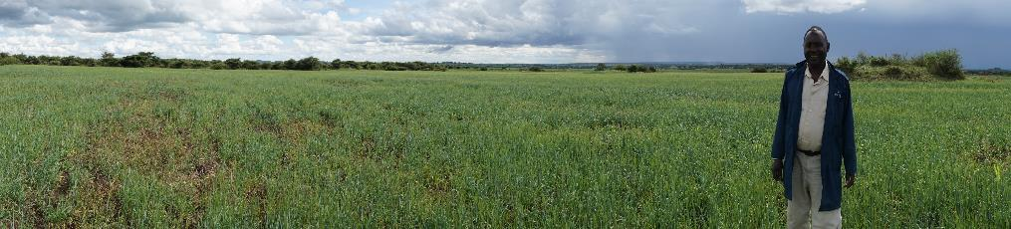**Farmers and informants met**

|  |  |
| --- | --- |
| Name | Contacts |
| West Kili |  |
| John Lington | 0753 662884 |
| Karoly Venansi | 0752071831 |
| Bon F Onsiki | 0754 081315 |
| Thomansi Venansi | 0689 447073 |
| Gadafi J. Kamirio | 0762990 995 |
| Kendyeo Mglamba | 0754 225948 |
| Thomasi M Mollel | 0757 780874 |
| Daniel Sandeva | 0754592808 |
| Juma Mingereza | 0782203646 |
| Hanang/Basuto | Names and contacts to follow |

1. More detailed objectives can be found in the original proposal
2. See Annex 1 for a list of farmers /staff consulted
3. except for 1 farmer at Katesh who said that rain was reliable in his area as it is very close to Mt Hanang